CLASS (7-10) SAMPLE IS TOO FEW

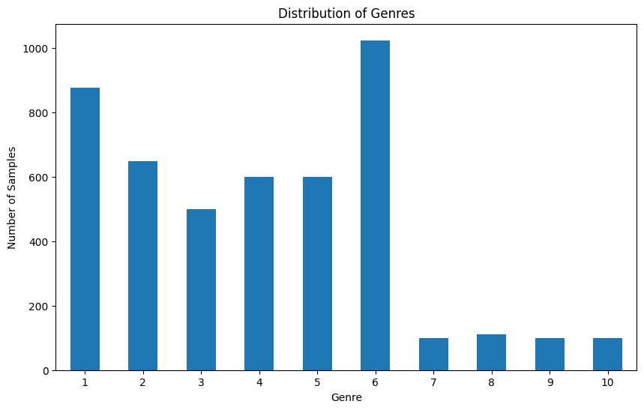
SUMMARY TOO SHORT, HAVE NO MEANING (> 4 WORDS)

Summaries with word count between 0 and 20 (inclusive):

 | summary_length_word | summary
12 | 16 | This book has yet to be published At this tim...
39 | 17 | A Crusader betrayed by a scheming emperor and...
55 | 14 | The novel concerns a man with a dream and an a...
155 | 9 | The novel concerns a man who is unnaturally ac...
319 | 14 | The novel concerns the quest of Magdalen Lorne...
338 | 1 | Receptio
351 | 19 | The novel concerns the swashbuckling adventure...
472 | 14 | Tor has given a short synopsis of the novel w...
529 | 13 | The novel tells the story of a professor who d...
541 | 18 | The novel concerns Earthmen who are overwhelme...
552 | 16 | The novel concerns Russian genetics experiment...
588 | 4 | Plot outline description
638 | 20 | The novel concerns a physicist who is trying t...
642 | 19 | The novel concerns a hero who combats aliens t...
692 | 13 | The novel concerns an international conspiracy...
710 | 16 | The novel is a space opera about a contemporar...
713 | 8 | Archform Beauty is set in 24th century Earth
805 | 19 | On the planet Barclow the Doctor and his comp...
830 | 18 | Guarding a colony expedition becomes much more...
834 | 4 | Plot outline description
835 | 19 | Lore Van de Oest was born in one of the mighti...
838 | 14 | The story features characters from the Medstar...
859 | 10 | Sarah Jane Smith encounters the Seventh Doctor...
877 | 16 | The novel concerns a tyrant that attempts to c...
907 | 10 | The novel concerns a lost race in the Gobi Desert
942 | 14 | Vir with the help of G Kar and Galen takes o...
960 | 12 | The novel concerns the first real estate boom ...
996 | 19 | The novel concerns people who are transported ...
1009 | 13 | The story begins with Tetsuya Ishigami and Yas...
1049 | 6 | The novel tackles themes of terrorism
1334 | 15 | Mike Hammer finds himself investigating a sex ...
1526 | 20 | Two English brothers travel across Europe as m...
1574 | 1 | Receptio
1743 | 19 | Man of Nazareth is a fictionalized historic ac...
1772 | 5 | Plot outline description
1776 | 20 | Howard Carter returns as a featured character ...
2015 | 8 | The novel is a Lovecraftian story of werewolves
2142 | 13 | The story begins with a thirty two year old Lo...
2273 | 16 | The novel concerns werewolves in the Connectic...
2312 | 10 | The novel concerns the vampire Don Sebastian i...
2410 | 1 | Character
2431 | 10 | The novel concerns the elephantine Great Old O...
2435 | 16 | The novel concerns vampires in the Connecticut...
2438 | 16 | The novel concerns mummies in the Connecticut ...
2485 | 3 | Plot outline description
2633 | 11 | As described by Sherryl Connelly of the New Yo...
2651 | 20 | Cuban exile Jimmy Columbus uses hijacking on t...
2933 | 17 | Locals from a small town cruise the rural back...
2936 | 11 | As described by Sherryl Connelly of the New Yo...
2967 | 11 | According to the description of the book by St...

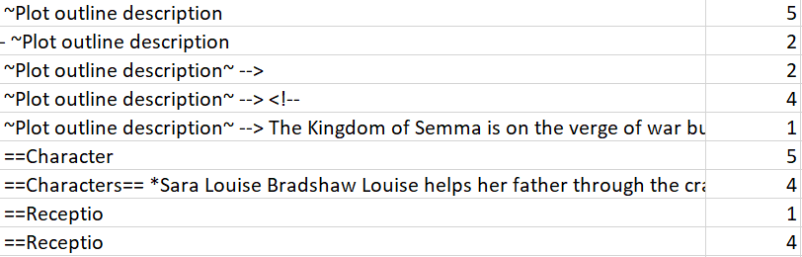
EXTREME SUMMARY LENGTH DIFFERENCE

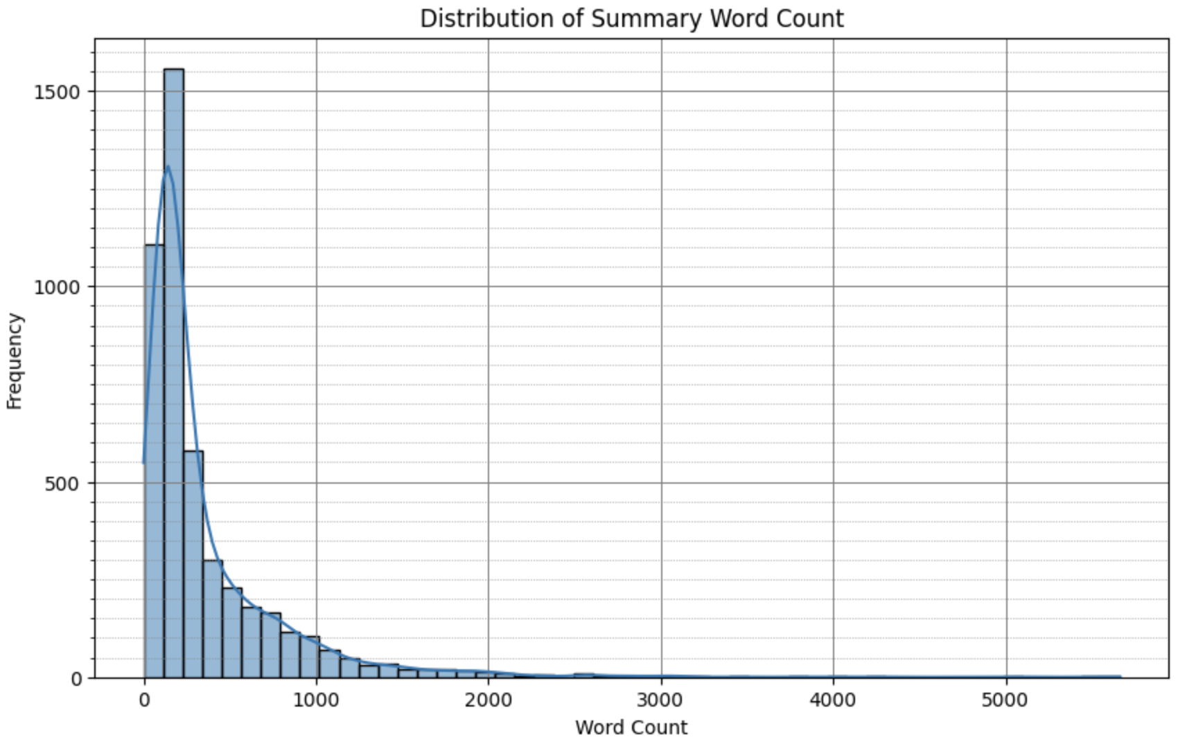
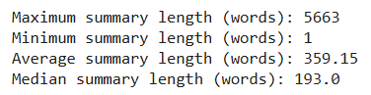
CORRUPTED DATASETS, IF FULLY CORRUPTED NEED TO BE REMOVED

Example : 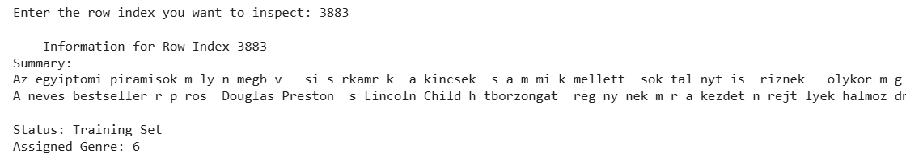

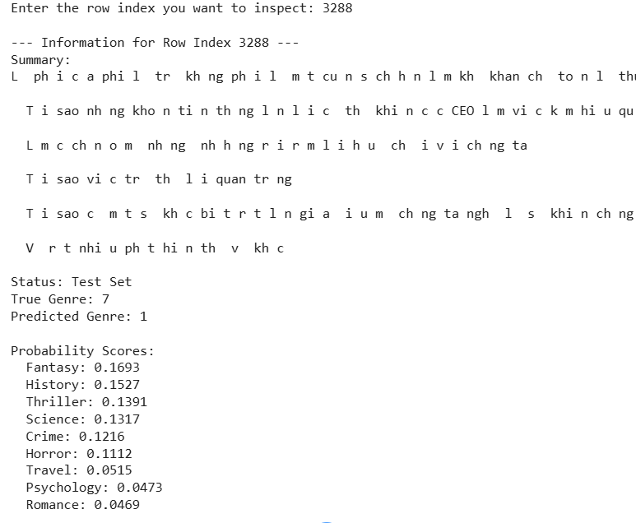

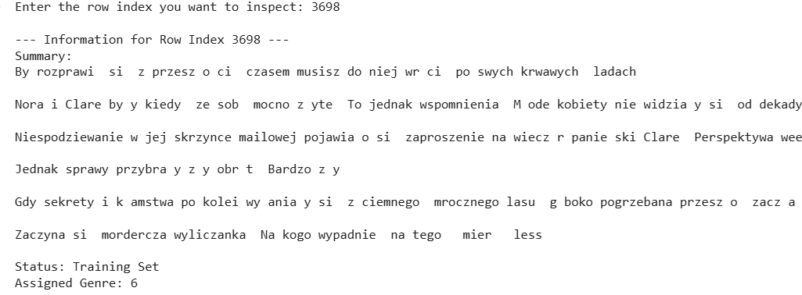

PARTIALLY CORRUPTED / INCLUDE SYMBOLS & CHARACTERS

Example :
NON ENGLISH WORDS



